CSI 4999 MIM System Software (MIMS) Project Report

**Authors:**

Brandyn Ureel

Daniel Matache

Mark Bruce

Michael Dashe

Katherine Schwartz

### Table of Contents:

1. Project vision

1.1. Backgrounds

1.2. Socio-economical Impact, Business Objectives, and Gap Analysis

1.3. Security and ethical concerns

1.4. Glossary of Key Terms

2. Project Execution and Planning

2.1. Team Information

2.2. Tools and Technology

2.3. Project Plan

2.4. Best standards and Practices

3. System Requirement Analysis

3.1. Function Requirements

3.2. Non-functional Requirements

3.3. On-Screen Appearance of landing and other pages requirements.

3.4. Wireframe designs

4. Functional Requirements Specification

4.1. Stakeholders 4.2. Actors and Goals

4.3. User stories, scenarios and Use Cases

4.4. System Sequence / Activity Diagrams

5. User Interface Specifications

5.1. Preliminary Design

5.2. User Effort Estimation

6. Static Design

6.1. Class Model

6.2. System Operation Contracts

6.3. Mathematical Model

6.4. Entity Relation

7. Dynamic Design

7.1. Sequence Diagrams.

7.2. Interface Specification

7.3. State Diagrams

8. System Architecture and System Design

8.1. Subsystems / Component / Design Pattern Identification

8.2. Mapping Subsystems to Hardware (Deployment Diagram)

8.3. Persistent Data Storage

8.4. Network Protocol

8.5. Global Control Flow

8.6. Hardware Requirement

9. Algorithms and Data Structures

9.1. Algorithms

9.2. Data Structures

10. User Interface Design and Implementation

10.1. User Interface Design

10.2. User Interface Implementation

11. Testing

11.1. Unit Test Architecture and Strategy/Framework

11.2. Unit test definition, test data selection

11.3. System Test Specification

11.4. Test Reports per Spring

12. Project Management

12.1. Project Plan

12.2. Risk management

13. References

## 1. Project vision

#### 1.1. Backgrounds

In 2016, law enforcement reported over 600,000 missing children nationwide. At this time, there remain over 80,000 missing from the original total. While this number increases each year, it is paramount to reduce the response time for public awareness of those that have been: (1) reported missing or (2) lured into human trafficking. In addition, the rise of human trafficking burdens the system for the half- million law enforcement (LE) officers nationwide. Unfortunately, missing children and victims of human trafficking are often unreported. Many parents are discouraged by the processes from making an official report to local authorities. Resources for retrieving proper investigatory leads are thereby limited for LE to launch proactive investigations. Instead, LE personnel are isolated to a reactive investigation that may sadly lead only to a recovery of the missing/exploited victim’s remains. It is essential that families of those that have gone missing or been a victim of human trafficking should be given the advantage of online digital tools to help in locating their missing loved ones. This project will address current deficiencies in publicizing information about missing persons and then facilitate enlisting of the public’s assistance in trying to locate these children.

#### 1.2. Socio-economical Impact, Business Objectives, and Gap Analysis

**Socio Economic Impact**

The Socio Economic Impact of Missing in Michigan application provides a resource for society to take control of reporting a missing person and leading the charge to gather information to allow Law Enforcement to monitor activity regarding missing people. This resource will be provided to communities to report information and post pictures on missing people in their areas. This impacts how society works together to help families find their missing loved ones. By making the MIMS available to the public, they can monitor and report information for parents and families to see. Law Enforcement will also be impacted to receive notifications directly from the families and the public to expedite their investigations.

**Business Objectives**

Business Objectives for the MIMS software is to minimize the gap of information regarding a missing person and to coordinate that information is a central tool. The goal is to circulate information between the parents, law enforcement, and the concerned public. The goals include the following:

* Allow parents to create a report on a missing person and make the information available for the public to view.
* Allow parents to coordinate missing person report with law enforcement.
* Allow members of the concerned public to report information on a missing person based on suspicious activity or reported sightings.
* Allow law enforcement to receive updated notification on reported activity.

The MIMS is a tool to push public awareness of missing people in the state of Michigan and give parents the assurance of taking action in controlling the awareness of their missing child.

**Gap Analysis**

|  |  |  |  |  |
| --- | --- | --- | --- | --- |
| **Sprint** | **Present State** | **Future State** | **Improvements** | **Action Plan** |
| **0** | MIM System Software Conception | Define project requirements and development environment. | Outline database and site mapping. | Completed |
| **1** | Project requirements defined tools and technologies researched for project. | Research and begin wireframes. Create user account registration functionality. | Create use cases, create base web application and server framework. | Completed |
| **2** | User account registration and login completed. | Allow users to create missing person report. | Refine project requirements and use cases/scenarios. | Completed |
| **3** | Generated report entities to allow user to create a missing person report. Project requirements redefined with project sponsor. | Front end development implemented for site navigation and back end development for missing person report. | Front end development and improve UI/UX. Additional completion of project documentation | Completed |
| **4** | Improved report entities to allow users to navigate between 6 pages to create missing person report. | Implement functionality to allow users to upload pictures to missing person profile. | Refine wireframes and improve UI/UX. Additional completion of project documentation. | Completed |
| **5** | Users able to upload pictures of missing person to report profile. | Implement functionality for public users to upload pictures and report information. | Refine wireframes and improve UI/UX. Additional completion of project documentation | Completed |
| **6** | Public users able to fill out important information of missing person. | Improvement to UI/UX for front end development. Completion of back end development. | Refine CSS and HTML for front end development. Improve UI/UX and additional completion of project documentation | Completed |
| **7** | CSS and HTML completed for UI/UX. Front and back end development completed. | All project requirements and functionality should be completed. | Finalize Project documentation and UI/UX for front end development | In-Progress |
| **8** | Front and Back end development completed. All project functionality completed and working. | All project requirements and functionality should be completed. | Prepare for project presentation for judges week. | In-Progress |

#### 1.3. Security and ethical concerns

The information which will be collected by this application, especially the personal information of the victims and their families, is sensitive. It is therefore imperative that the application strikes the correct balance between informing the public to help locate the victim and protecting the privacy of all innocent people involved. The availability of such information must be limited and security measures to protect it implemented. We will accomplish this by allowing different levels of access for different users, so the family of the victims can share information with law enforcement that is not available to the general public. We must also ensure that the front-end code is secure and non-exploitable, and that querying of the database is done in such a way that a user cannot force application to return information that they shouldn’t have access to.

Also, when gathering information about the victim’s contacts, we must be sure to stay within the bounds of the law. Accessing certain information from third-parties, such as cell service providers, can introduce legal problems and may require a warrant[1]. Therefore, we must ensure the application will only obtain information through legal avenues, such as voluntary input by families of victims.

#### 1.4. Glossary of Key Terms

* **MIMS Software**
  + **Missing in Michigan System Software**: Software application that is designed to allow parents to create a missing person report to expedite the creation and sharing of pertinent information between law enforcement, parents, and the concerned public.
* **Law Enforcement**
  + A system in which members of society act in an organized manner to enforce the law by discovering, deterring, rehabilitating, or punishing people who violate the rules and norms governing that society.
* **Law Enforcement Officer**
  + A member of law enforcement whose duty primarily involves enforcing the law.
* **Lead Investigator**
  + A member of law enforcement who is appointed as the lead investigator for a missing person case. The investigator is the lead detective assigned to the missing person case once a report has been created by a parent in the MIMS application and a police report has been filed by law enforcement.
* **Concerned Public**
  + Any member of society that enlists to aid the search process of finding a missing person. The responsibility of the concerned public is to report any critical information pertaining to a missing person that may assist law enforcement in furthering their investigation.
* **Missing Person Report**
  + A detailed report created in the MIMS application that contains information on the missing person. Information may include the name, age, height, weight, hair color, and last known location.
* **Last Known Location**
  + The last physical know location of where a missing person was last seen.
* **Associated Family and Friends**
  + Any family member or friend that may have had contact with the missing person and may have pertinent information on locating the missing person.
* **Complaint Number**
  + The identification number from the police report filed by law enforcement to allow users to link to the missing person report in the MIMS application.
* **Police Report**
  + Detailed report created by law enforcement of a missing person and is distributed within the national missing and unidentified person database.
* **Report Number**
  + The identification or case number of the police report filed by law enforcement to allow users to link to the missing person report in the MIMS application.
* **Geofence**
  + A geographic boundary, defined by GPS, that enables the MIMS application to track known locations of where the missing person usually visits.

## 2. Project Execution and Planning

#### 2.1. Team Information

Members:

###### Brandyn Ureel

* + Major: Information Technology
  + Front and Back End Developer

###### Daniel Matache

* + Major: Information Technology
  + Lead Project Documenter
  + Project Planner

###### Mark Bruce

* + Major: Information Technology
  + Lead Wireframe designer

###### Michael Dashe

* + Major: Information Technology
  + Lead Database Designer
  + Front End CSS developer

###### Katherine Schwartz

* + Major: Computer Science
  + Front and Back End Developer
  + Agile Developer

#### 2.2. Tools and Technology

* Angular
  + Angular (also known as Angular2) is an open-source web application framework. Angular projects are coded in TypeScript (a superset of JavaScript). It is modular and designed for speed and ease of use.
  + Angular is a powerful framework for building application frontends. It has extensive documentation, and members of our team are already familiar with it.
* Cucumber
  + Cucumber is an open-source software testing tool. There are Cucumber implementations in a variety of different programming languages, including Java, Python, and Ruby. It uses the Gherkin language to define tests. Gherkin is easily readable and allows both programmers and non-programmers to define unambiguous tests.
  + Cucumber provides an adequate testing tool for our project. Tests in Cucumber are easy to define and can be written by any member of the team. Perhaps most importantly, an implementation is available in the language we wish to test (Java).
* Gradle
  + Gradle is an open-source tool that automates the process of creating a software build. It supports many languages and platforms. It prioritizes efficiency and performance. It is designed to cater especially to large and complex builds.
  + Gradle provides an adequate tool for managing and automating our project’s software build.
  + Multi-language, multi-platform tool commonly used and heavily supported by community
* MySql
  + MySQL is a free relational database system. It is commonly used in many domains. Though originally released in 1995, it is still actively maintained. It is currently owned by Oracle Corporation.
  + Relational database system is suitable for our data
  + Available on multiple platforms (Windows, Mac, Linux)
  + Part of XAMPP stack
* PostgreSql
  + PostgreSQL (also referred to as Postgres) is an open-source relational database system. It is used in many domains, including by popular websites such as Reddit and Instagram. Though originally released in 1996, it is still actively maintained by the PostgreSQL Global Development Group.
  + Relational database system is suitable for our data
  + Available on multiple platforms (Windows, Mac, Linux)
  + PostgreSQL is reliable, mature, and free.
* Spring Boot
  + Spring is an open-source application framework for the Java platform. It is modular by design, allowing programmers to choose from a suite of modules that provide various services.
  + Spring Boot allows easy creation of Spring application
  + Spring is a widely-used and powerful Java-based application framework
* XAMPP
  + XAMPP is an Apache web server distribution containing the MySQL database and the PHP scripting language. It is designed to simplify the process of running a local web server for testing purposes.
  + Single solution for entire development server stack
* [Face_recognition by ageitgey](https://github.com/ageitgey/face_recognition)
  + Face_recognition is a facial recognition project sourced from GitHub and has a MIT free use licence
  + “The world's simplest facial recognition api for Python and the command line”
  + Requires
    - Python
    - Dlib with Python settings
    - Linux or MacOS
* Adobe XD Beta
  + User experience design software
  + Developed and published by Adobe Systems
  + Supports Vector design and Wireframing
* JHipster
  + Free and open-source application generator
  + Used to develop MIMS Web Application
  + Develop Microservices using Angular and the Spring Framework.
* Maven
  + Open-source build automation system that builds upon the concepts of Apache Ant and Apache Maven
  + Introduces a Groovy-based Domain-specific Language instead of XML for declaring the project configuration
* Docker
  + Software technology providing containers
  + Provides an additional layer of abstraction and automation of operating system level virtualization on Windows and Linux
  + Packages an application and its dependencies in a virtual container

#### 2.3. Project Plan

**Sprint 0**



**Sprint 1**

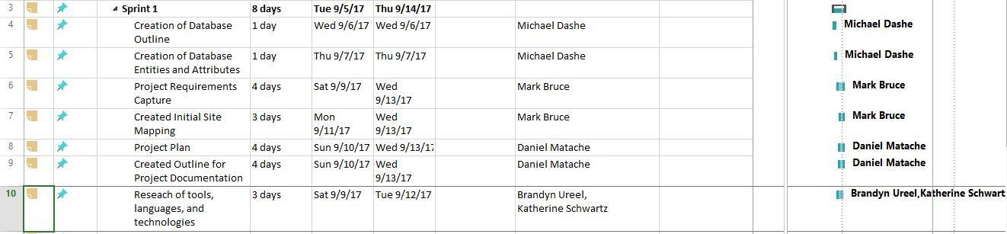

**Sprint 2**

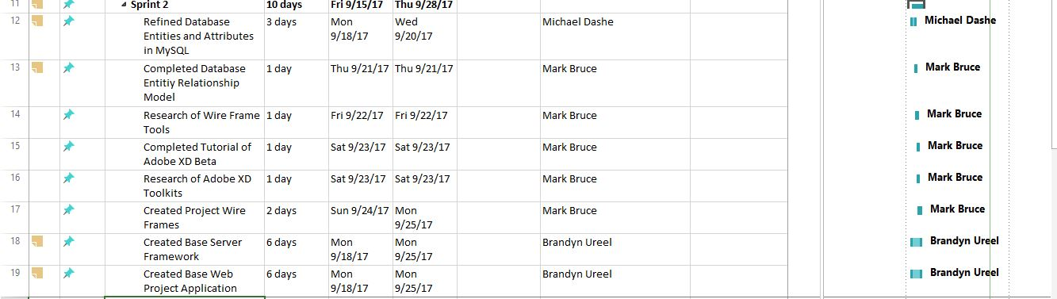

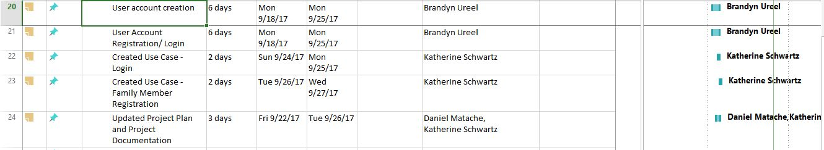

**Sprint 3**

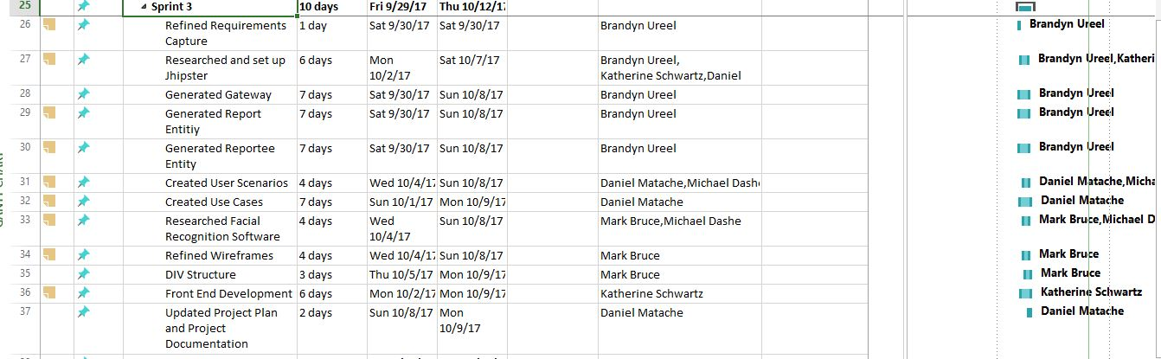

**Sprint 4**

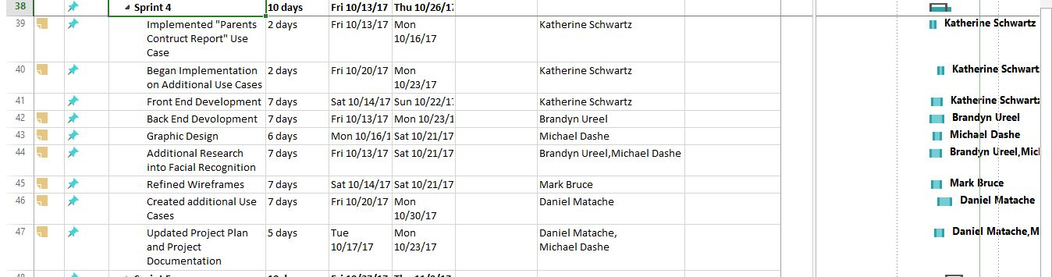

**Sprint 5**

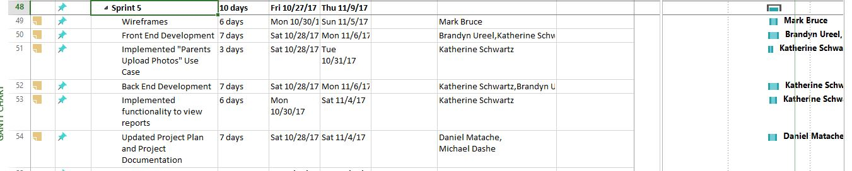

**Sprint 6**

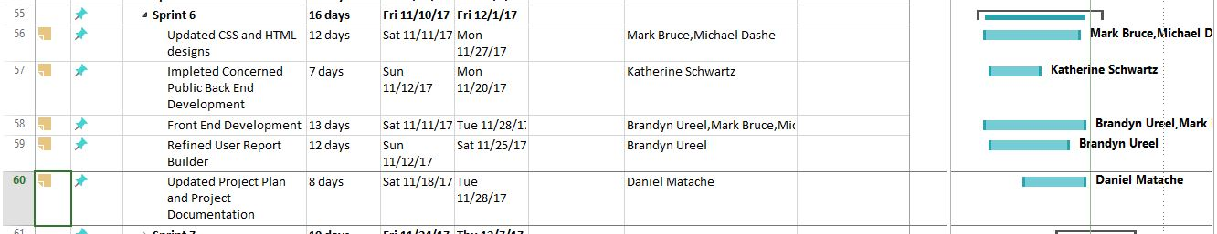

**Sprint 7**

**Sprint 8**

#### 

#### 2.4. Best standards and Practices

Standards

* Follow agile method
* Test-First programming
* Continuous Integration
* Share codebase between developers
* Work in Github to share code
* Merge code at end of each sprint

Best Practices

* Research project objectives and plan requirements
* Plan project infrastructure
* Design API for project requirements and develop further once requirements are met
* Test what needs to be tested routinely
* Write code for only what is required and will be implemented
* Merge code to main branch and back up code
* Implement one function at a time and build on existing functions
* Decide on a unified development process
* Break down plan by sprints and commit changes each sprint
* Assign individual task to be completed per sprint

## 3. System Requirement Analysis

#### 3.1. Functional Requirements

* Create an account
* Create a Missing person profile
* E-mail law enforcement
* Log back in
* Print off report
* Citizen submit a report
* Search and display missing persons

#### 3.2. Non-functional Requirements

* Facial recognition search/confirmation
* Uploading photos
* E-mail parents notifications
* Confirmation of users
* Find nearest police station

#### 3.3. On-Screen Appearance of landing and other pages requirements.

* Have the landing page display a layout of missing children's pictures last seen in the area.
* Have a page to notify users and have them agree to terms of legal disclaimer.
* Have a clean layout that is easy and intuitive to use.
* Have forms easy to understand and intuitive to fill in.
* Make things as straightforward as possible to both parents and Concerned Public

#### 3.4. Wireframe designs

**Login Portal**

**Create Account Page:**

**Login Page:**

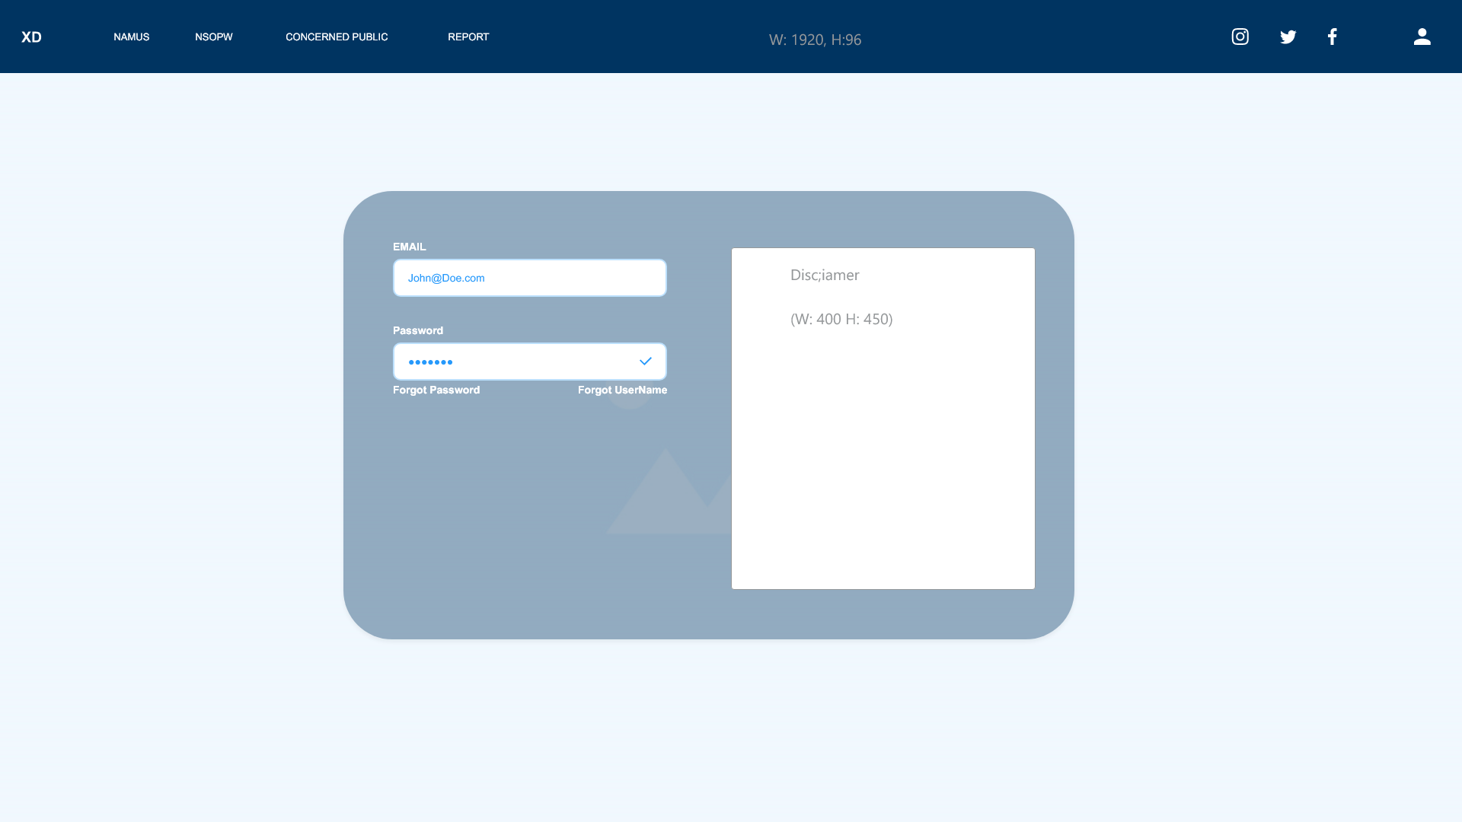

**Password Reset Page:**

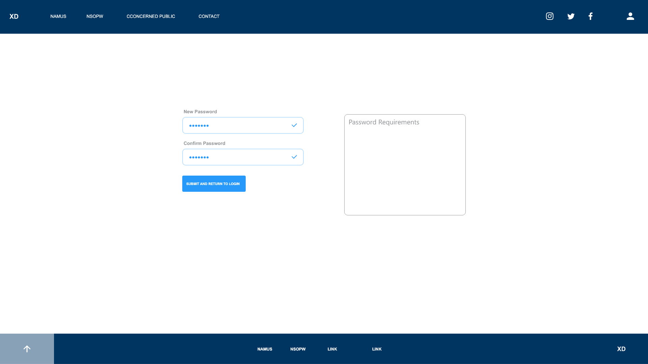

**Password Recovery:**

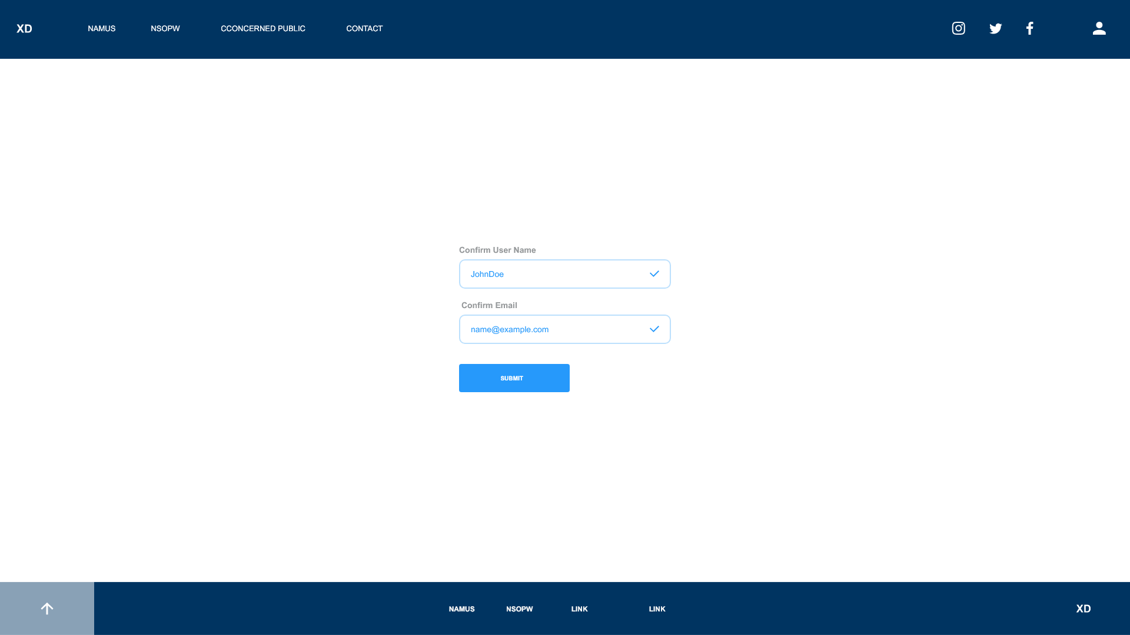

**Parent’s Portal**

**Law Enforcement Form:**

**Point of Contact Form:**

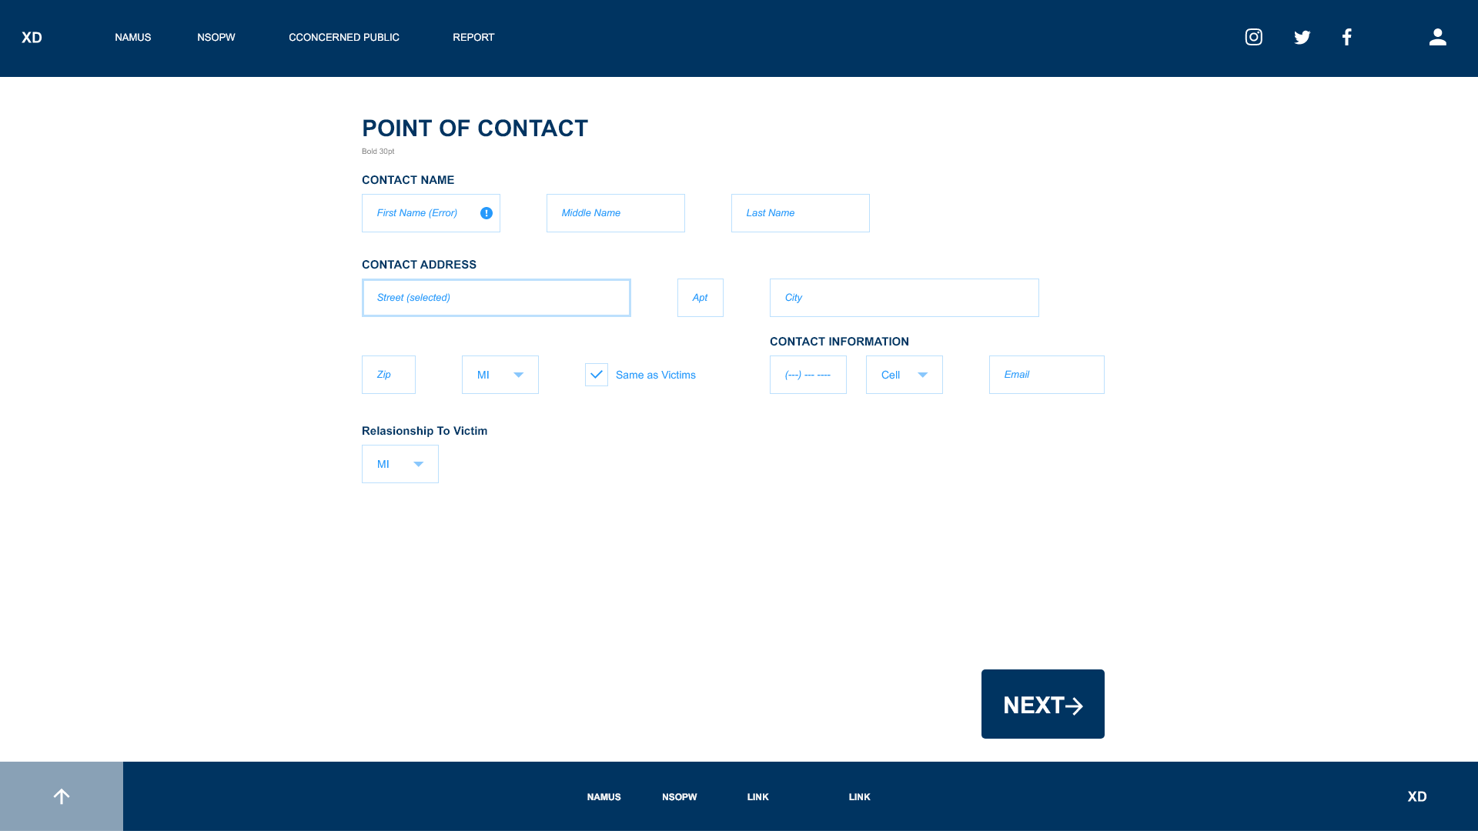

**Victims Personal Information Form:**

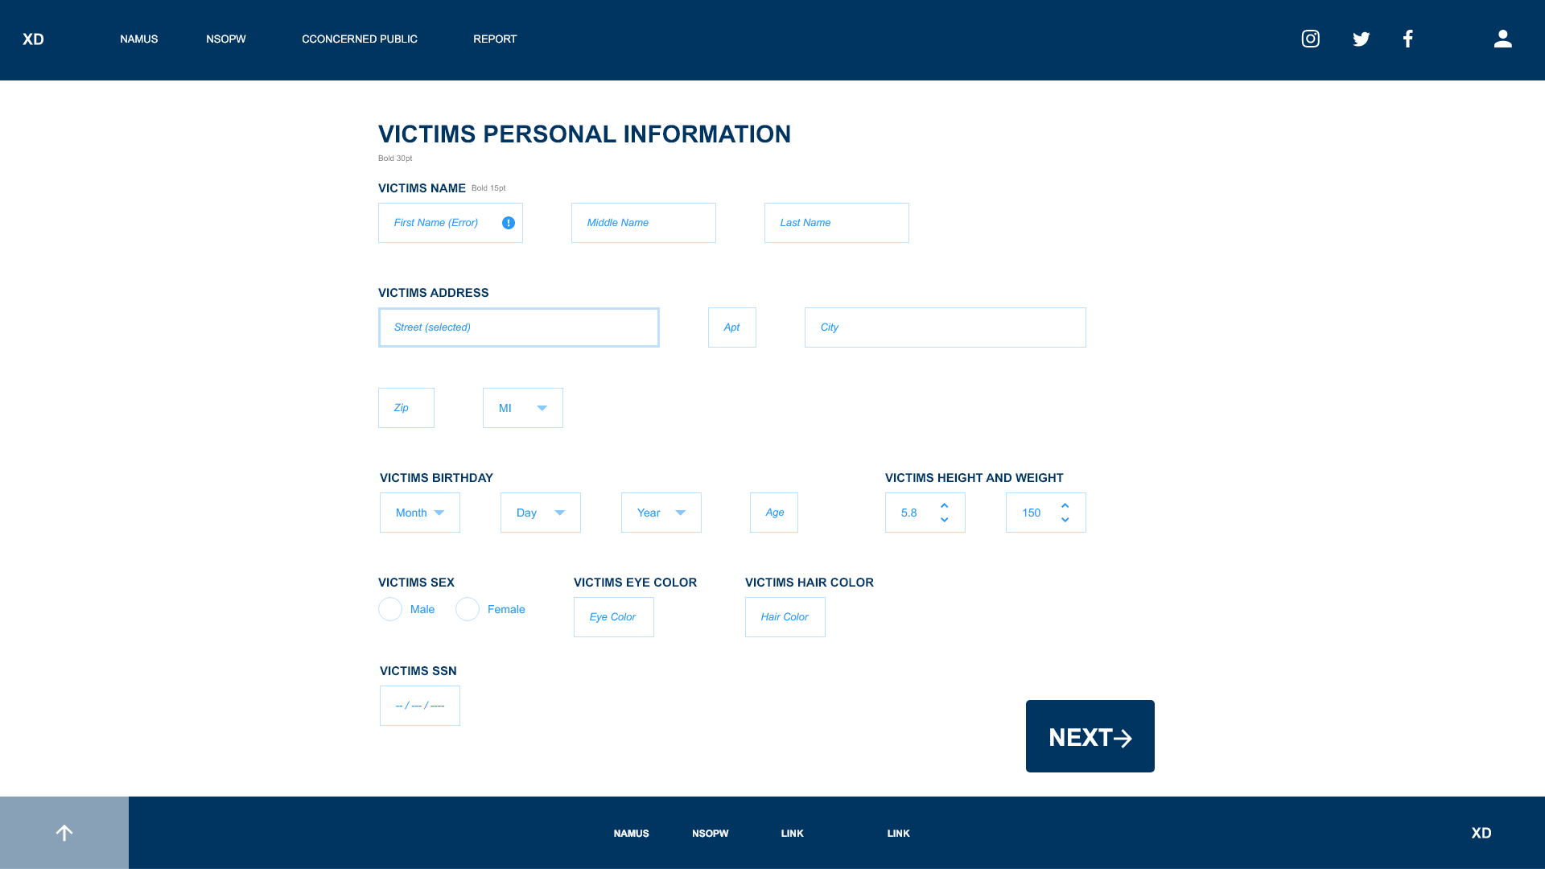

**Victim Personal Details Form:**

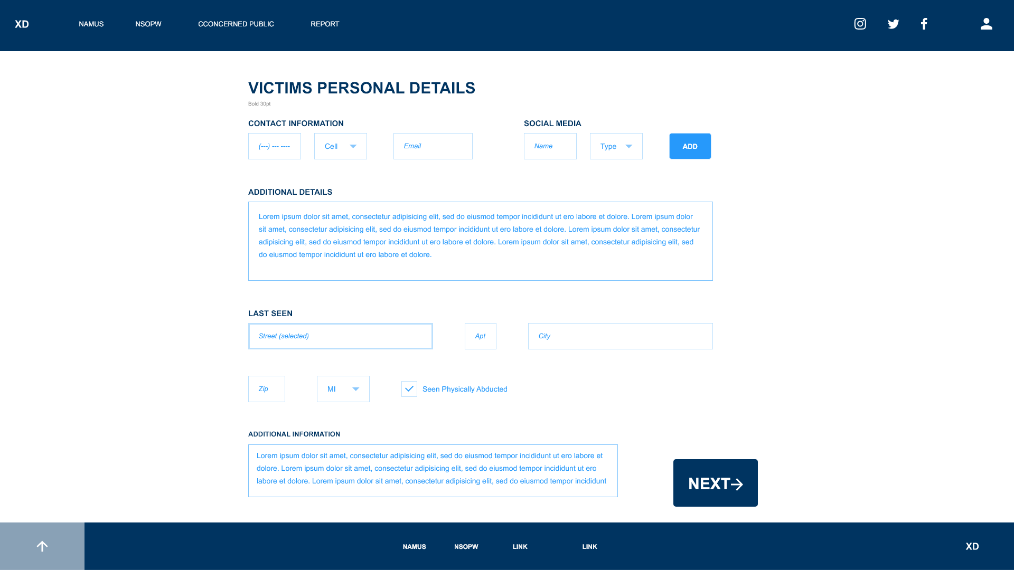

**Victims Contacts Form:**

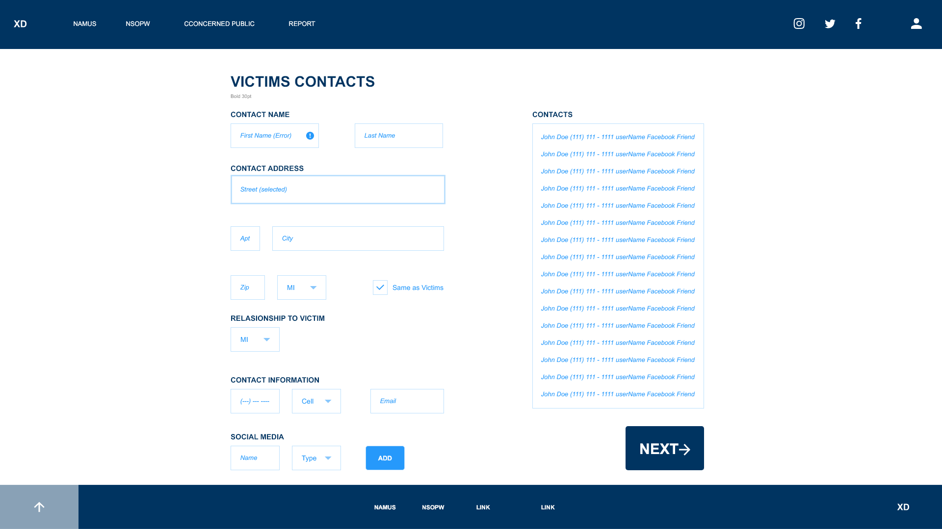

**Victims Photographs Form:**

**Parents Information Form:**

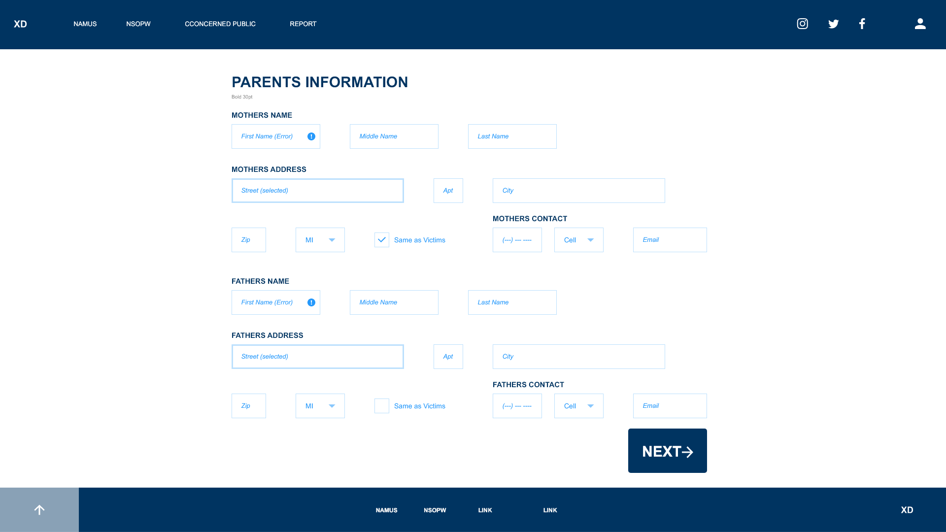

**Missing Person Report Navigation Page:**

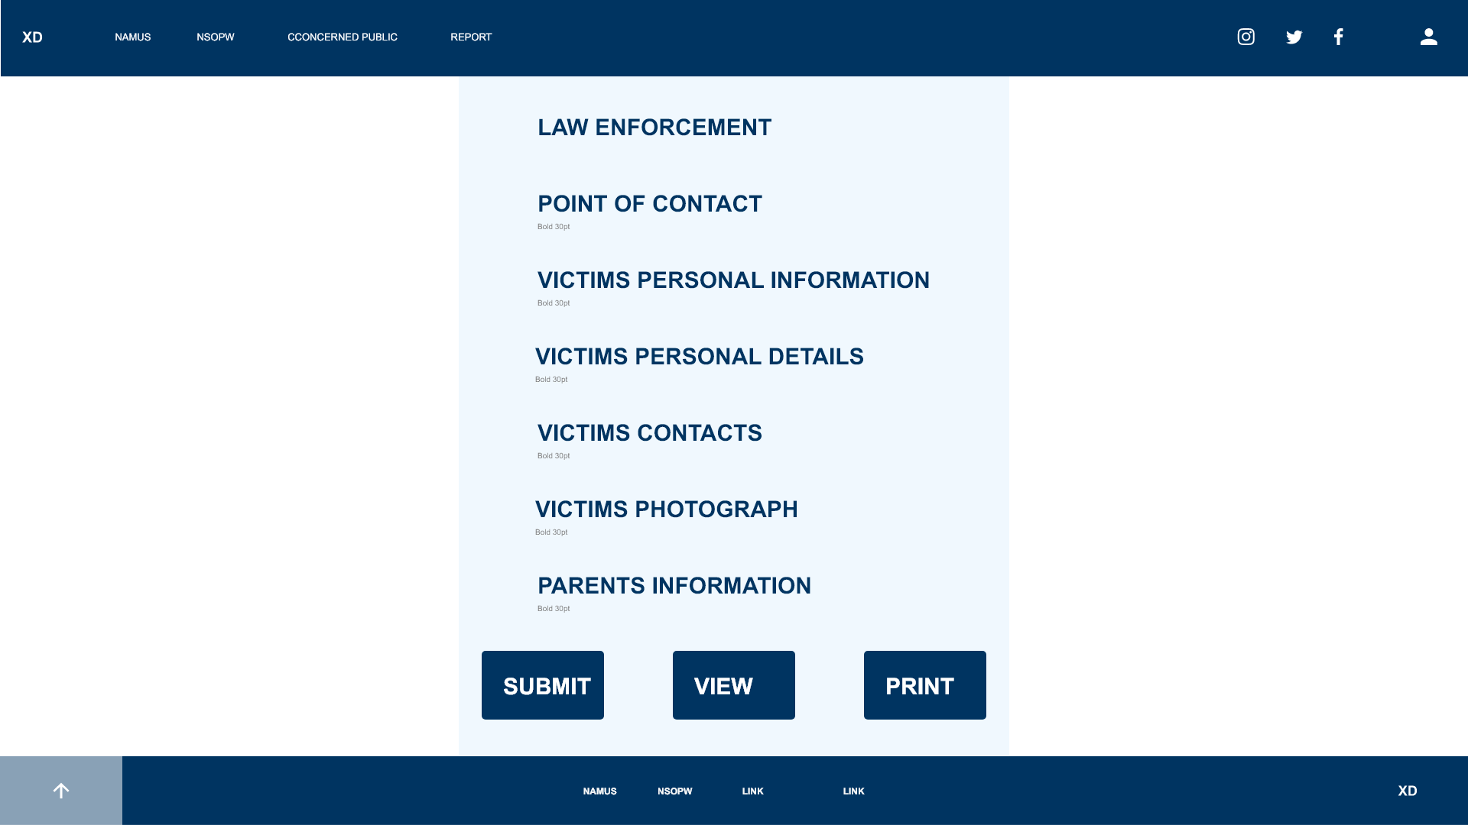

**Concerned Public Portal**

**Concerned Public Disclaimer Agreement:**

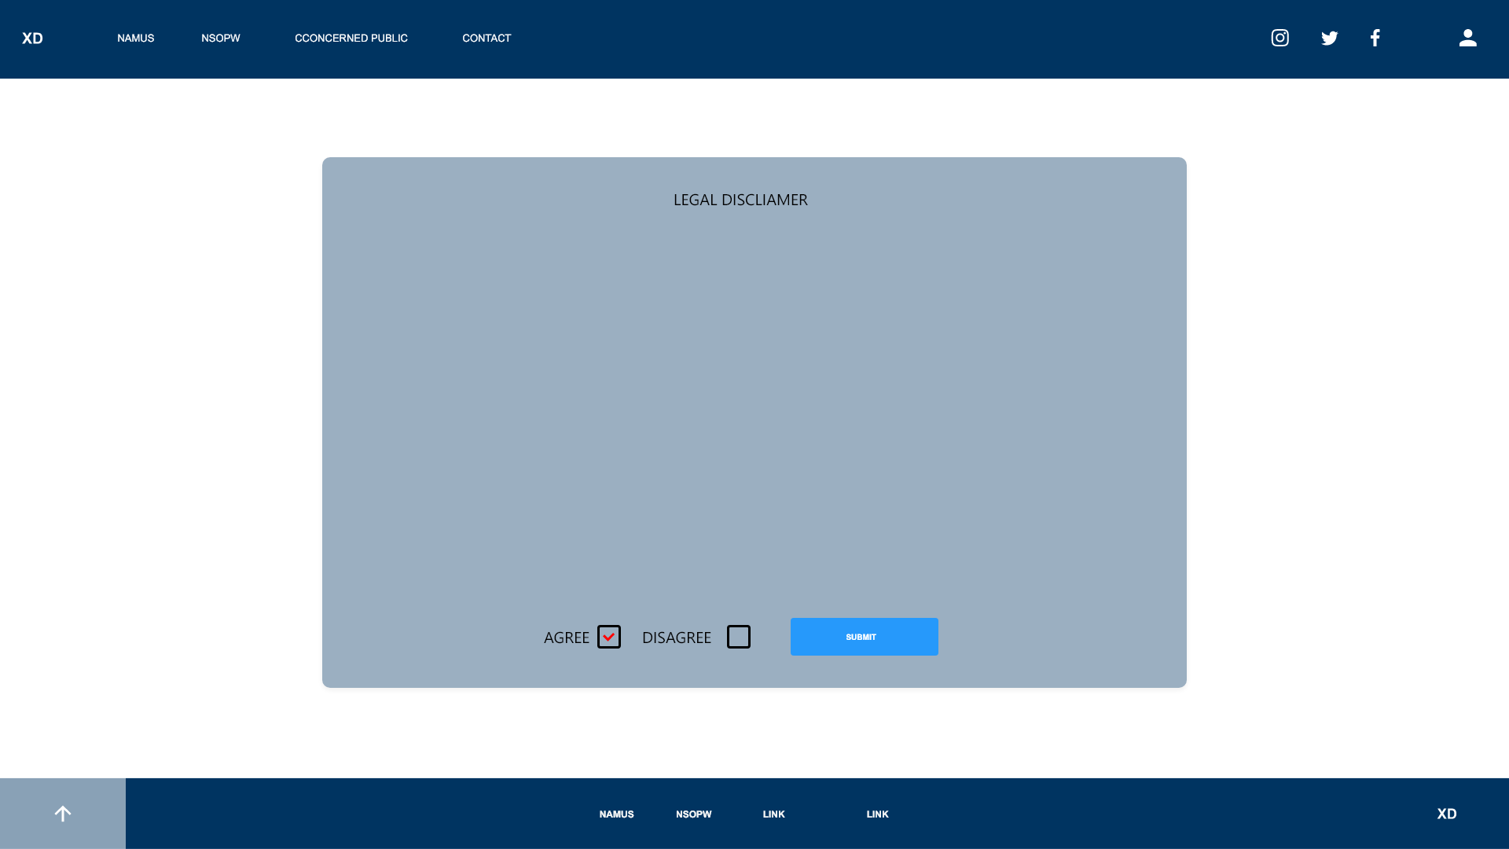

**Concerned Public Landing Page:**

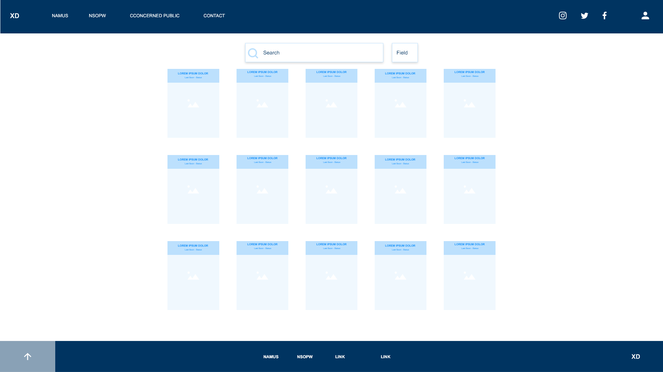

**Concerned Public Victim's Profile Page:**

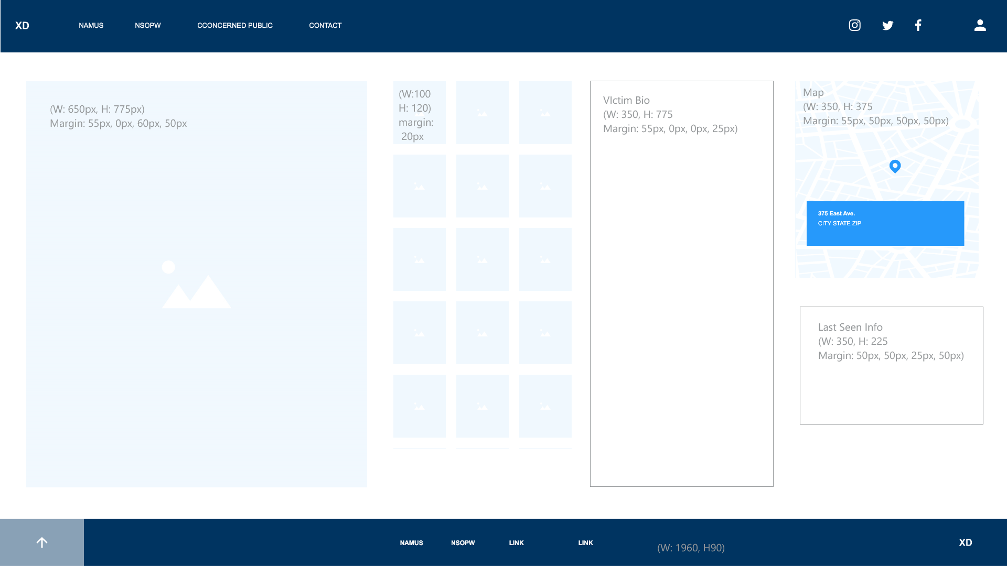

## 4. Functional Requirements Specification

#### 4.1. Stakeholders

The stakeholders of the MIM System Software are primarily the parents and family members of the missing person and law enforcement.

* Families: The largest stakeholders of the MIM System Software are families who will have the advantage of online digital tools to help locate their missing loved ones. By investing in the MIM System Software, families will be able to take charge in sharing pertinent information between them and law enforcement and help expedite the process of finding the missing person.
* Law Enforcement: The second stakeholder of the MIM System Software is law enforcement who will use the system to obtain notifications from families and concerned public using the MIM System to report missing individuals. Law Enforcements is challenged to maintain organization when a person is missing. By investing in the MIM System Software, law enforcement will be able to control the process and workflow to locate a missing person.

#### 4.2. Actors and Goals

* Parents: Mother and Father of the missing person. Their goal is to report information of their missing child and use the MIM system to enter pertinent information describing their child, such as height, weight, demographics, DOB, and photographs.
* Law Enforcement: Police Officers searching for the missing person. Their goal is to receive email notifications from parents, friends, and the concerned public reporting on the missing person.
* Friends: Close friends of the families of the missing person. Their goal is to be identified for investigatory purposes to reduce those involved.
* Concerned Public: Any member of the public that sees or has information about the missing person that they can report and make available for the investigation process. Their goal is to report any information they find regarding a location of the missing person and upload an image of the suspected missing person.

#### 4.3. User stories, scenarios and Use Cases

**User Stories**

**Parents**

* As a Parent, I want to be able to create an account.
* As a Parent, I want, to be able to log into my account.
* As a Parent, I want to be able to construct a missing person report and enter information on weight, height, eye color, hair color, gender, demographic, etc.
* As a Parent, I want to be able to enter the names and contact information of friends and family members of the missing person.
* As a Parent, I want to be able to enter the phone service provider and master account phone number of the missing person.
* As a Parent, I want to be able to upload pictures of the missing person.
* As a Parent, I want to be able to enter the last known location of the missing person.
* As a Parent, I want to be able to print out the missing person report into a PDF file for the police report.
* As a Parent, I want to be able to enter the law enforcement information such as, complaint number, report number, and law enforcement investigator’s email address.

**Law Enforcement**

* As Law Enforcement, I want to receive email notifications with updates about a missing person.

**Concerned Public**

* As a concerned public, I want to view a missing person’s report profile.
* As a concerned public, I want to enter information regarding a suspected missing person.
* As a concerned public, I want upload pictures of a suspected missing person.
* As a concerned public, I want to enter the location and time seen of the suspected missing person.

**User Scenarios**

**Parents:**

Jane and John are parents who enjoy spending time with their children. One Saturday morning, Jane and John decide to take their family to their local park. John takes their youngest son Colin to playground at the park to play on the swings. As John and Colin play, Jane shouts out to them to come back to get the picnic started. John allows Colin to go play with other kids at the park while he goes and helps Jane.After John and Jane are finished setting up the picnic, they call out to Colin to get some food. Colin doesn’t respond and they go searching for him. They cannot seem to find him anywhere in the park and the other kids he was playing with do not know where he went. After an hour has passed and still unable to find Colin, Jane calls the police. Since colin has not been missing for at least 24 hours, the operator advised Jane to file a report on the Missing In Michigan System Software (MIMS).

Jane and John have never used the MIMS application and need to set up a verified account to get started. They go to the MIMS website and click register to create an account. Jane enters her name, email address, username, and password and clicks the register button. Her account is created and she clicks the login button to login. Once logged in, she navigates to report page on the site to create a new report. She need to provide an accurate description of Colin based on his full name, address, height, weight, demographic, sex, date of birth, eye color, hair color, as well as any identifying marks. She then clicks next to fill out additional information. She fills out contact information with the names of family members and friends that know Colin and the family. She then uploads recent pictures of Colin and enters the address of the park where Colin was last seen and went missing. Once she completes the required information to create the missing person report, she submits the report online. She then prints out a PDF copy of the report that she can take to the police station and file a police report.

At the police station, Jane and John sit down with a Detective Moriarty and hands over the printed police report from the MIMS application. Detective Moriarty creates and files a official police report for Colin based on the report Jane and John printed. The police report contains the complaint number, report number, and Detective Moriarty’s email address. Jane logs back into the MIMS application and navigates to Colin’s profile. She navigates to the law enforcement information page and enters in the complaint number, report number, and Detective Moriarty’s email address. The detective is now linked as the lead investigator on Colin’s case by his email address.

Jane and John now wait, hoping to information to come in about Colin.

**Concerned Public:**

Sara is a member of society and an advocate on helping parents find their missing children. She is familiar with the MIMS application and frequently uses the application in hope of providing details if she ever sees suspected missing people in the public. Since she is a member of the concerned public, she is not required to create an account. Sara lives near the park that Colin went missing. She views the list of missing people on the MIMS application on Monday. She notices Colin’s profile and sees that he went missing at the park. She decides to drive around the area to see if she finds anything. She arrives in the parking lot of the park. As she sits in her car, she hears a noise of a screaming child. She sees a boy matching Colin’s description along with an older man. She pulls up Colin’s missing person profile and enters a tip of what she saw and the location and time where she saw the child. She then takes a picture on her phone of the man and the boy and uploads the picture to Colin’s profile. She hopes that information will help the police find Colin.

**Law Enforcement:**

Detective Moriarty is the lead investigator of Colin’s case. By providing Jane and John the police report information along with his email address, he is now able to receive email notifications of any updates made to Colin’s profile. After Sara submits her tip and picture of what she at the park, Detective Moriarty receives an email notification with that information. He is able to determine that the boy in the picture is Colin and takes a unit to investigate the location. After driving around the park they spot the same man in the picture Sara took. They follow that man home and upon hearing screams they breach the house and find Colin inside. They take Colin home back to his parents.

The MIMS application is designed to push public awareness of missing people in the state of Michigan and give parents the assurance of taking action in controlling the awareness of their missing child by expedite the process of reporting and searching for a missing person.

**Use Cases**

1. Parent Registration

|  |  |
| --- | --- |
| **Name:** | Parent Registration |
| **Description:** | This use case describes how a parent would register for the MIMS application |
| **Actors:** | Parents – a mother or father of one of the victims who is missing and wants register and account for the MIMS application |
| **Preconditions:** | None |
| **Trigger:** | The parent navigates to the registration page |
| **Basic Flow:** | 1. The family member is prompted to provide personal details, consisting of:  · First name  · Last name  · Relation to victim  · Email address  · Phone number  · Street number  · Street name  · City  · Zip code  · State  · Password  2. The parent enters all of the requested information  3. The parent clicks the “Register” button  4. An account is created for the parent and the parent is redirected to the main page |
| **Exception Flow:** | 1. The parent is prompted to provide personal details, consisting of:  · First name  · Last name  · Relation to victim  · Email address  · Phone number  · Street number  · Street name  · City  · Zip code  · State  · Password  2. The parent enters invalid/incomplete information  3. The parent clicks the “Register” button  4. The parent is shown a message indicating that the information is invalid/incomplete |
| **Post Conditions:** | · An account is created for the parent  · The parent has been redirected to the main page |

1. User Login

|  |  |
| --- | --- |
| **Name:** | User Login |
| **Description:** | This use case describes how a registered user would log in to the MIMS application. |
| **Actors:** | User – a member of one of two groups of people who have user accounts- either a parent or family member of a victim. |
| **Preconditions:** | The user already has an account |
| **Trigger:** | The use case begins when the user navigates to the login page. |
| **Basic Flow:** | 1. The user is prompted to enter an email address and password  2. The user enters valid credentials  3. The user clicks the “Login” button  4. The user is logged into the system and redirected to their main page |
| **Exception Flow:** | 1. The user is prompted to enter an email address and password  2. The user enters invalid credentials  3. The user clicks the “Login” button  4. The user is shown a message indicating that the credentials are invalid |
| **Post Conditions:** | ·The user is logged into the system  · The user has been redirected to the main page |

1. Parents Construct Report

|  |  |
| --- | --- |
| **Name:** | Parent Constructs Report |
| **Description:** | This use case describes how a parent would construct a report of a missing child in the MIMS application |
| **Actors:** | Parent – the mother or father of one of the missing person who wants to construct a report on their missing child |
| **Preconditions:** | The parent must have already registered an account and be logged into their account |
| **Trigger:** | The parent clicks on the “Report” Button. |
| **Basic Flow:** | 1. The parent is prompted to provide personal details of the missing person, consisting of:  ● First name  ● Last name  ● Gender  ● Date of Birth  ● Height  ● Weight  ● Eye Color  ● Hair Color  ● Marks/Tattoos  ● Phone number  2. The parent enters all of the requested information  3. The parent clicks the “Create Report” button  4. The Missing person report is created and the parent is redirected to the missing person profile page. |
| **Exception Flow:** | 1. The parent is prompted to provide personal details of the missing person, consisting of:   ● First name  ● Last name  ● Gender  ● Date of Birth  ● Height  ● Weight  ● Eye Color  ● Hair Color  ● Marks/Tattoos  ● Phone number  2. The parent enters invalid/incomplete information  3. The parent clicks the “Create Report” button  4. The parent is shown a message indicating that the information is invalid/incomplete |
| **Post Conditions:** | ● The Missing person report is created  ● The parent is redirected to the missing person profile page. |

1. Family Friends Information

|  |  |
| --- | --- |
| **Name:** | Parents Enter Missing Person’s Friends and Family Information |
| **Description:** | This use case describes how a parent enters in their missing child’s friends and family information. |
| **Actors:** | Parent – the mother or father of one of the missing persons who filed a missing person report and enters family and friends information |
| **Preconditions:** | The parent must be logged into their account and have already reported a missing person. |
| **Trigger:** | The parent navigates to the family/friends information page |
| **Basic Flow:** | 1. The parent is prompted to provide personal details, consisting of:  · First name  · Last name  · Email address  · Phone number  · Street number  · Street name  · City  · Zip code  · State    2. The parent enters all of the requested information  3. The parent clicks the “Update” button  4. The Family/Friends information is added to the Missing person’s profile page and the parent is redirected to the missing person’s profile page. |
| **Exception Flow:** | 1. The parent is prompted to provide personal details, consisting of:  · First name  · Last name  · Relation  · Email address  · Phone number  · Street number  · Street name  · City  · Zip code  · State  2. The parent enters invalid/incomplete information  3. The parent clicks the “Update” button  The parent is shown a message indicating that the information is invalid/incomplete |
| **Post Conditions:** | · The information for the family member/friend is created  · The parent has been redirected to the missing person profile page |

1. Enter Master Phone account

|  |  |
| --- | --- |
| **Name:** | Parent Registration |
| **Description:** |  |
| **Actors:** |  |
| **Preconditions:** |  |
| **Trigger:** |  |
| **Basic Flow:** |  |
| **Exception Flow:** |  |
| **Post Conditions:** |  |

1. Last Known location

|  |  |
| --- | --- |
| **Name:** | Parents Enter Last Known Location |
| **Description:** | This use case describes how a parent enters in the last known location of their missing child in the MIM application |
| **Actors:** | Parent – the mother or father of one of the missing person who filed a missing person report and enters the last known location of the missing person. |
| **Preconditions:** | The parent must be logged into their account and have already reported a missing person. |
| **Trigger:** | The parent navigates to the “Last Known Location” Section |
| **Basic Flow:** | 1. The parent is prompted to provide personal details, consisting of:  · Location Name  · Street number  · Street name  · City  · Zip code  · State  · Time    2. The parent enters all of the requested information  3. The parent clicks the “Update” button  The Last Known Location is added to the Missing person’s profile page and the parent is redirected to the missing person’s profile page. |
| **Exception Flow:** | 1. The parent is prompted to provide personal details, consisting of:  · Location Name  · Street number  · Street name  · City  · Zip code  · State  · Time  2. The parent enters invalid/incomplete information  3. The parent clicks the “Update” button  4. The parent is shown a message indicating that the information is invalid/incomplete |
| **Post Conditions:** | · The information for the Last Known Location is created  · The parent has been redirected to the missing person profile page |

1. Parents Upload Pictures

|  |  |
| --- | --- |
| **Name:** | Parent Uploads Pictures |
| **Description:** | This use case describes how a parent uploads pictures of the missing child in the MIMS application |
| **Actors:** | Parents – a mother or father of one of the victims who is missing and wants to upload pictures of their missing child |
| **Preconditions:** | * The parent must have already registered an account and currently be logged into the application. * The parent must have already constructed a missing person report. |
| **Trigger:** | The parent clicks on the “Upload Pictures” button. |
| **Basic Flow:** | 1. The parent is prompted to select photos from their device  2. The parent selects the 15 pictures on their device.  3. The parent clicks the “Upload” button  4. The pictures of the missing person are upload to the missing person profile page and the parent is taken to the missing person profile page. |
| **Exception Flow:** | 1. The parent is prompted to select photos from their device to upload.  2. The parent selects less than 15 photos  3. The parent clicks the “Upload” button  4. The parent is shown a message indicating that they need to select at least 15 pictures |
| **Post Conditions:** | •The pictures of the missing person are uploaded to the missing person profile page •The parent has been redirected to the missing person profile page |

1. Parents Print Police Report

|  |  |
| --- | --- |
| **Name:** | Parent Print Police Report |
| **Description:** | This use case describes how a parent would print out a police report based on the report they created of the missing child in the MIMS application. |
| **Actors:** | Parent – the mother or father of one of the missing person who wants to print out the police report of their missing child |
| **Preconditions:** | The parent must have already constructed a report on a missing person and navigate to the missing person report page. |
| **Trigger:** | The parent clicks on the “Print” Button. |
| **Basic Flow:** | 1. The MIMS application exports the report of the missing person into a PDF file.  2. The parent selects their printer on their computer.  3. The parent clicks print.  4. The report is printed into a police report. |
| **Exception Flow:** | 1. The MIMS application exports the report of the missing person into a PDF file  2. The parent does not have a printer installed on their computer.  3. The parent is prompted to save the PDF file of the police report on their computer.  The parent will need to print the report once they have a printer installed. |
| **Post Conditions:** | · The Missing person police report is printed.  · The parent is redirected to the missing person profile page  The parent is redirected to the missing person profile page |

1. Parents enter LE information

|  |  |
| --- | --- |
| **Name:** | Parent Enters Law Enforcement Information |
| **Description:** | This use case describes how a parent enters the police report information in the missing child in the MIMS application |
| **Actors:** | Parent – the mother or father of one of the missing person who wants enters the police report information in the missing child in the MIMS application. |
| **Preconditions:** | The parent must have already printed out the police report and taken it to the police station to get the investigation started |
| **Trigger:** | The parent navigates to the “Law Enforcement Information” section |
| **Basic Flow:** | 1. The parent is prompted to provide the police report details, consisting of:  · Complaint number  · Report Number  · Law Enforcement Investigator Email Address  2. The parent enters all of the requested information  3. The parent clicks the “Update” button  4. The law enforcement information is updated to the missing person report page. |
| **Exception Flow:** | 1. The parent is prompted to provide the police report details, consisting of:  · Complaint number  · Report Number  · Law Enforcement Investigator Email Address  2. The parent enters invalid/incomplete information  3. The parent clicks the “Update” button  4. The parent is shown a message indicating that the information is invalid/incomplete |
| **Post Conditions:** | · The Law Enforcement Information Section is updated on the missing person profile page.  · The parent is redirected to the missing person profile page.  · The Law Enforcement Investigator’s email address is linked to the missing person. |

1. Law Enforcement receives email

|  |  |
| --- | --- |
| **Name:** | Law Enforcement Receives Email Updates |
| **Description:** | This use case describes how member law enforcement receives email notifications regarding missing child in the MIMS application |
| **Actors:** | Law Enforcement – a member of law enforcement who is the lead investigator on the case of the missing person and receives email notifications with updates on the missing person from the MIMS application |
| **Preconditions:** | The law enforcement investigator must have their email address listed as the lead investigator on a Missing Person Report. |
| **Trigger:** | The Missing Person’s Report is updated with any information from a parent, family member, or concerned public. |
| **Basic Flow:** | 1. The missing person’s report is updated with any of the following information:  · Parent constructs a report of a missing child  · Parent uploads images of a missing child  · Parent enters associated family/friends information  · Member of the public uploads images of the suspected missing person  · Member of the public reports a location/ time of the suspected missing person  · The member of the public reports any tips of the suspected missing person  2. The MIMS application sends an email to the law enforcement investigator with the update made on the missing person report.  3. The law enforcement investigator receives an email with the update. |
| **Exception Flow:** | 1. The missing person’s report is updated with any of the following information:  · Parent constructs a report of a missing child  · Parent uploads images of a missing child  · Parent enters associated family/friends information  · Member of the public uploads images of the suspected missing person  · Member of the public reports a location/ time of the suspected missing person  · The member of the public reports any tips of the suspected missing person  2. The law enforcement investigator does not have their email address listed as the lead investigator on a Missing Person Report.  3. The MIMS application does not send an email to the law enforcement investigator with the update made on the missing person report.  4. The law enforcement investigator does not receive an email with the update. |
| **Post Conditions:** | The law enforcement investigator receives an email with the update |

1. Public views profiles

|  |  |
| --- | --- |
| **Name:** | Public Views Missing Person Profiles |
| **Description:** | This use case describes how member of the concerned public views the profile of missing people in the MIMS application |
| **Actors:** | Public – a member of the concerned public who wants to view profiles of missing people. |
| **Preconditions:** | The member of the public must have the MIMS application pulled up. |
| **Trigger:** | The member of the public clicks on the “Missing People” button |
| **Basic Flow:** | 1. The member of the public is taken to a page showing profiles of all current missing people  2. The member of the public can scroll through the list of missing people.  3. The member of the public clicks on a missing person profile. |
| **Exception Flow:** | 1. The member of the public is taken to a page showing profiles of all current missing people  2. There are no profiles of any missing people |
| **Post Conditions:** | The profiles of the missing people are displayed on the screen |

1. Public Reports tips

|  |  |
| --- | --- |
| **Name:** | Public Reports Tips |
| **Description:** | This use case describes how member of the concerned public report tips regarding the suspected missing child in the MIMS application. |
| **Actors:** | Public – a member of the concerned public who sees a missing person and wants to report tips they have on the suspected missing person in public |
| **Preconditions:** | The member of the public must have the MIMS application pulled up and be in the missing person profile page |
| **Trigger:** | The member of the public clicks on the “Report Tips” button. |
| **Basic Flow:** | 1. The member of the public is prompted to enter any information they may have regarding a suspected missing person in a textbox.  2. The member of the public enters information in the textbox.  3. The member of the public clicks the “Report Tips” button  4. The information of the reported tips that the member of the public have are updated on the missing person profile page and the member of the public is taken to the missing person profile page. |
| **Exception Flow:** | 1. The member of the public is prompted to enter any information they may have regarding a suspected missing person in a textbox.  2. The member of the public enters no information in the text box.  3. The member of the public clicks the “Report Tips” button  4. The member of the public is shown a message indicating that the information is invalid/incomplete. |
| **Post Conditions:** | * The information of the reported tips that the member of the public have are updated on the missing person profile page. * The member of the public is taken to the missing person profile page. |

1. Public Reports location

|  |  |
| --- | --- |
| **Name:** | Public Reports Location |
| **Description:** | This use case describes how member of the concerned public reports the location and time of a missing child in the MIMS application |
| **Actors:** | Public – a member of the concerned public who sees a missing person and wants to report the location and time they saw the suspected missing person in public. |
| **Preconditions:** | The member of the public must have the MIMS application pulled up and be in the missing person profile page |
| **Trigger:** | The member of the public clicks on the “Report Location/Time” button. |
| **Basic Flow:** | 1. The member of the public is prompted to provide the following information, consisting of:  · Street number  · Street name  · City  · Zip code  · State  · Time  2. The member of the public enters all of the requested information.  3. The member of the public clicks the “Report Location/Time” button  4. The information of the reported location and time that the member of the public saw are updated on the missing person profile page and the member of the public is taken to the missing person profile page. |
| **Exception Flow:** | 1. The member of the public is prompted to provide the following information, consisting of:  · Street number  · Street name  · City  · Zip code  · State  · Time  2. The member of the public enters invalid/incomplete information.  3. The member of the public clicks the “Report Location/Time” button  4. The member of the public is shown a message indicating that the information is invalid/incomplete |
| **Post Conditions:** | * The information of the reported location and time that the member of the public saw are updated on the missing person profile page * The member of the public is taken to the missing person profile page |

1. Public uploads Pictures

|  |  |
| --- | --- |
| **Name:** | Public Uploads Pictures |
| **Description:** | This use case describes how member of the concerned public uploads pictures of a missing child in the MIMS application |
| **Actors:** | Public – a member of the concerned public who sees a missing person and wants to upload pictures the suspected missing person in public |
| **Preconditions:** | The member of the public must have the MIMS application pulled up and be in the missing person profile page. |
| **Trigger:** | The member of the public clicks on the “Report Pictures” button. |
| **Basic Flow:** | 1. The member of the public is prompted to select a picture(s) from their device to upload.  2. The member of the public selects pictures on their device.  3. The member of the public clicks the “Upload” button  4. The pictures of the suspected missing person are upload to the missing person profile page and the member of the public is taken to the missing person profile page. |
| **Exception Flow:** | 1. The member of the public is prompted to select a picture(s) from their device to upload.  2. The member of the public selects an invalid image file.  3. The member of the public is shown a message indicating that the file type they selected is invalid. |
| **Post Conditions:** | ·The pictures of the suspected missing person are uploaded to the missing person profile page  · The member of the public has been redirected to the missing person profile page |

#### 4.4. System Sequence / Activity Diagrams

## 5. User Interface Specifications

#### 5.1. Preliminary Design

#### 5.2. User Effort Estimation

## 6. Static Design

#### 6.1. Class Model

#### 6.2. System Operation Contracts

#### 6.3. Mathematical Model

#### 6.4. Entity Relation

## 7. Dynamic Design

#### 7.1. Sequence Diagrams.

#### 7.2. Interface Specification

#### 7.3. State Diagrams

## 8. System Architecture and System Design

#### 8.1. Subsystems / Component / Design Pattern Identification

#### 8.2. Mapping Subsystems to Hardware (Deployment Diagram)

#### 8.3. Persistent Data Storage

#### 8.4. Network Protocol

#### 8.5. Global Control Flow

#### 8.6. Hardware Requirement

## 9. Algorithms and Data Structures

#### 9.1. Algorithms

#### 9.2. Data Structures

## 10. User Interface Design and Implementation

#### 10.1. User Interface Design

#### 10.2. User Interface Implementation

## 11. Testing

#### 11.1. Unit Test Architecture and Strategy/Framework

#### 11.2. Unit test definition, test data selection

#### 11.3. System Test Specification

#### 11.4. Test Reports per Spring

## 12. Project Management

#### 12.1. 11.1 Project Plan

#### 12.2. 11.2 Risk management

## 13. References

[1] Telephone Records and Privacy Protection Act of 2006, Pub. L. No. 109-476, 120 STAT. 3568 (2006).